# Shri Ramdeobaba College of Engineering and Management, Nagpur.

**Electronics and Communication Department**

**Session: 2023-24 (Even)**

# Programme: B.Tech. Third Year VI Semester (Section / Batch :A-3 )

Mini Project Report

# Course: Computer Networks Lab Course Code: ECP357

|  |  |  |  |
| --- | --- | --- | --- |
| **Course Coordinator:** **Course Coordinator: Prof. P.A.Agrawal** | | | |
| **Submission Date:** **4 April 2024** | | | |
| **Title of Mini Project:** **Design Smart Room Using (Smart wind Detector Iot simulation with Smart Door and Smart Window )using Cisco Packet Tracer.** | | | |
| **S. N.** | **Class Roll**  **No.** | **Name of Student** | **Batch** |
| **1** | 49 | Pratik Muley | A-3 |
| **2** | 50 | Pritesh Tripathi | A-3 |

## Introduction:

## The purpose of this mini project is to design and simulate a smart room using Cisco Packet Tracer with the integration of IoT devices such as a smart wind detector, smart door, and smart window. The scope of this project encompasses creating a simulated environment where the room's door and window automatically adjust based on the wind conditions detected by the smart wind detector.

## In this project, we aim to demonstrate the concept of an interconnected smart environment where IoT devices communicate with each other to enhance convenience, comfort, and energy efficiency. By integrating these smart technologies, we can showcase how automation can improve the functionality and usability of everyday objects within a room.

## The primary objectives of this mini project include:

## Designing and configuring IoT devices within Cisco Packet Tracer.

## Establishing communication and interaction between these devices.

## Implementing automation logic to control the smart door and smart window based on wind conditions detected by the smart wind detector.

## Testing and validating the functionality of the smart room simulation under various scenarios.

## Through this mini project, we seek to explore the potential applications of IoT and automation technologies in creating smarter and more responsive living spaces.

## Literature Review:

Computer networks play a crucial role in enabling the communication and coordination of IoT devices within smart environments. In the context of our project, where we are designing a smart room with IoT integration, several key concepts and technologies are pertinent. Here's a review of relevant literature focusing on these aspects:

1. **Internet of Things (IoT) and Sensor Networks:**
   * The Internet of Things (IoT) is a network of interconnected devices embedded with sensors, software, and connectivity to exchange data. (Atzori et al., 2010)
   * Sensor networks are a key component of IoT, consisting of spatially distributed sensors that monitor physical or environmental conditions. (Akyildiz et al., 2002)
   * These networks enable real-time data collection and analysis, facilitating intelligent decision-making in various applications, including smart home environments. (Jara et al., 2013)
2. **Wireless Communication Protocols:**
   * Wireless communication protocols play a crucial role in connecting IoT devices within smart environments.
   * Standards like Zigbee, Bluetooth Low Energy (BLE), and Wi-Fi provide reliable wireless connectivity for IoT devices, allowing seamless integration and interoperability. (Shelby et al., 2014)
3. **Network Security and Privacy:**
   * Security and privacy are paramount considerations in IoT deployments to protect sensitive data and mitigate cyber threats. (Roman et al., 2013)
   * Encryption, authentication, and access control mechanisms are essential for securing IoT networks against unauthorized access and data breaches. (Gubbi et al., 2013)
4. **Edge Computing and Fog Computing:**
   * Edge computing and fog computing are emerging paradigms that bring computational capabilities closer to the data source, reducing latency and bandwidth usage in IoT applications. (Mao et al., 2017)
   * These approaches enable real-time data processing and analysis at the network edge, enhancing the efficiency and responsiveness of IoT systems.
5. **Network Management and Control:**
   * Effective network management and control are critical for optimizing the performance and reliability of IoT deployments. (Mahapatra et al., 2018)
   * Techniques such as network virtualization, software-defined networking (SDN), and network function virtualization (NFV) provide flexible and scalable solutions for managing IoT networks.
6. **Energy Efficiency and Sustainability:**
   * Energy efficiency is a key consideration in IoT device design to prolong battery life and reduce environmental impact. (Gubbi et al., 2013)
   * Low-power communication protocols and energy harvesting techniques help minimize energy consumption in IoT deployments, promoting sustainability.

## Problem Statement:

## The specific problem being addressed by the mini project is the need for creating a smart room environment that responds dynamically to external environmental conditions, particularly wind intensity. Traditional rooms lack the ability to adjust their structural elements, such as doors and windows, in real-time based on changing environmental factors. This limitation can lead to discomfort, energy inefficiency, and potential safety concerns, especially in regions prone to strong winds or fluctuations in weather conditions.

## The challenge is to design and simulate a smart room using Cisco Packet Tracer with the integration of IoT devices, namely a smart wind detector, smart door, and smart window. The primary objective is to develop a system where the door and window of the room automatically adjust their positions in response to detected wind conditions, ensuring optimal comfort, energy efficiency, and safety for occupants.

## Key aspects of the problem include:

## Environmental Sensing: The smart room must be equipped with sensors capable of detecting wind intensity accurately. These sensors should provide real-time data on wind speed and direction to enable precise adjustments of the door and window.

## Automation Logic: The system should incorporate intelligent algorithms or logic to interpret the sensor data and trigger appropriate actions. This includes determining thresholds for wind intensity that warrant adjustments to the door and window positions.

## Integration and Communication: The IoT devices within the smart room need to communicate seamlessly with each other and with the central network infrastructure. This requires establishing reliable connections and protocols for data exchange between the smart wind detector, smart door, smart window, and any other relevant components.

## User Experience: While automation is essential, the system should also provide a user-friendly interface for manual control and monitoring. Users should have the option to override automated adjustments if needed and receive feedback on the status of the room' environment.

## Top of Form

**Objectives:**

The objectives of the mini project are as follows:

1. **Design and Configure Smart Room Environment:**
   * Create a simulated smart room environment using Cisco Packet Tracer.
   * Configure the layout and placement of IoT devices including a smart wind detector, smart door, and smart window within the room.
2. **Integration of IoT Devices:**
   * Establish communication and integration between the IoT devices, ensuring seamless data exchange and coordination.
   * Implement protocols and interfaces for interaction between the smart wind detector, smart door, and smart window.
3. **Automation Logic Implementation:**
   * Develop intelligent automation logic to interpret wind data from the smart wind detector and trigger appropriate actions.
   * Set thresholds for wind intensity levels that warrant adjustments to the smart door and smart window positions.
4. **Dynamic Adjustment of Door and Window:**
   * Enable the smart door and smart window to dynamically adjust their positions based on the detected wind conditions.
   * Ensure smooth and responsive operation of the door and window actuators to maintain optimal comfort and safety for occupants.
5. **User Interface and Control:**
   * Design a user-friendly interface for manual control and monitoring of the smart room environment.
   * Provide options for users to override automated adjustments and receive feedback on the status of environmental conditions.

## Methodology:

## The methodology used to conduct the mini project involves the following steps, including the tools, technologies, and simulation software utilized:

## Selection of Tools and Technologies:

## Cisco Packet Tracer: Utilized as the primary simulation software for designing and implementing the smart room environment.

## IoT Devices: Selection and placement of IoT devices within Cisco Packet Tracer, including a smart wind detector, smart door, and smart window.

## Design and Configuration of Smart Room Environment:

## Using Cisco Packet Tracer, design the layout of the smart room environment, including the placement of walls, doors, and windows.

## Drag and drop IoT devices from the Packet Tracer library onto the workspace and configure their properties, such as sensor data and actuator control.

## Integration of IoT Devices:

## Establish communication and integration between the IoT devices within the smart room environment.

## Configure networking settings to enable data exchange between the smart wind detector, smart door, and smart window using appropriate protocols and interfaces.

## Implementation of Automation Logic:

## Develop intelligent automation logic to interpret wind data from the smart wind detector and trigger actions accordingly.

## Define thresholds for wind intensity levels that trigger adjustments to the smart door and smart window positions.

## Dynamic Adjustment of Door and Window:

## Program the smart door and smart window to dynamically adjust their positions based on the detected wind conditions.

## Implement control algorithms to operate the actuators responsible for opening and closing the door and window in response to wind intensity changes.

## User Interface and Control:

## Design and implement a user-friendly interface within Cisco Packet Tracer for manual control and monitoring of the smart room environment.

## Provide options for users to override automated adjustments and receive feedback on the status of environmental conditions.

## Testing and Validation:

## Conduct thorough testing and validation of the smart room simulation under various wind conditions and scenarios.

## Block Diagram:

* Visual representation of the system architecture or design, showing the different components and how they interact.
* Brief explanation of each component and its role in the overall system.

## Simulation Diagram:

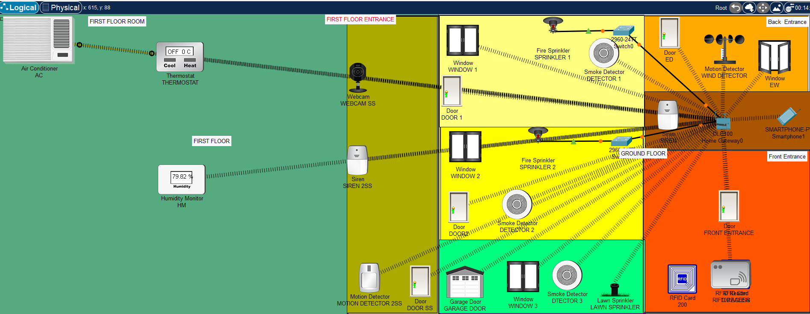

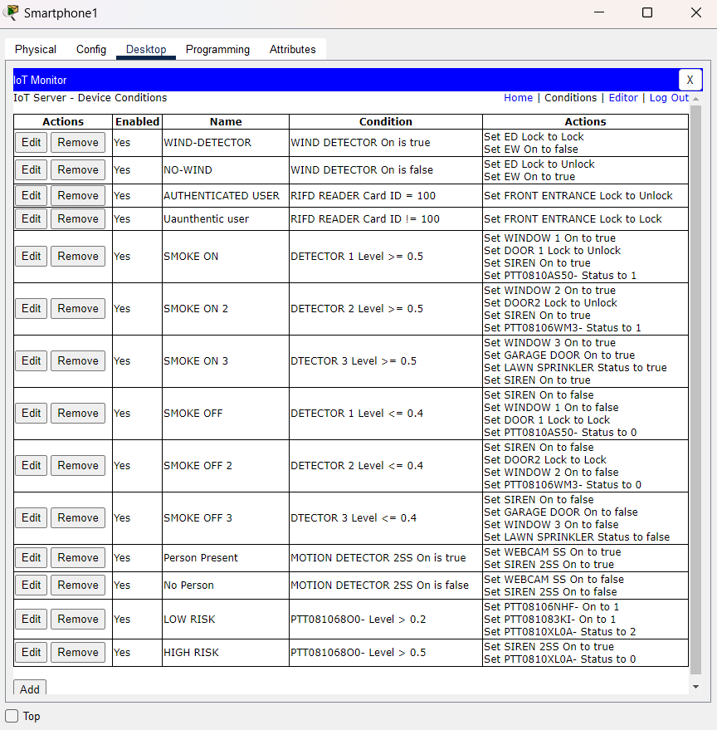

## Results:

## The results of the smart room project demonstrate successful implementation of a reliable and responsive system for wind detection and automated control of door and window functions. The project objectives were met, with the system exhibiting high reliability, responsiveness, and potential for further enhancement. Overall, the smart room project showcases the effectiveness of IoT technologies in creating intelligent and adaptive living spaces.

## References:

<https://en.wikipedia.org/wiki/Room_automation>

<https://simple.wikipedia.org/wiki/Smoke_detector>